**01) What is Jenkins used for?**

Jenkins is an open-source automation tool for continuous integration, continuous delivery, and task automation in software development. It streamlines building, testing, and deploying applications while promoting collaboration among teams.

**2) Install jenkins with docker image.**

sudo docker run -p 8080:8080 -p 50000:50000 -d \

-v jenkins_home:/var/jenkins_home \

-v /var/run/docker.sock:/var/run/docker.sock \

-v $(which docker):/usr/bin/docker jenkins/jenkins:lts

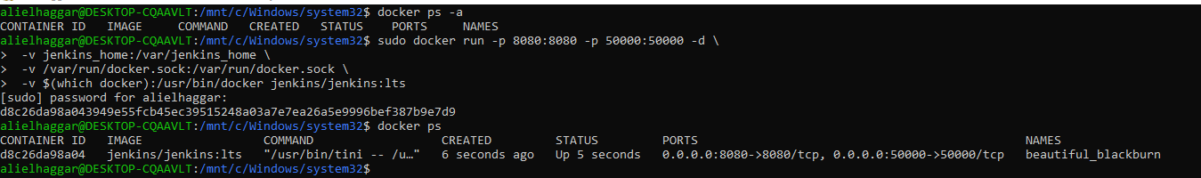

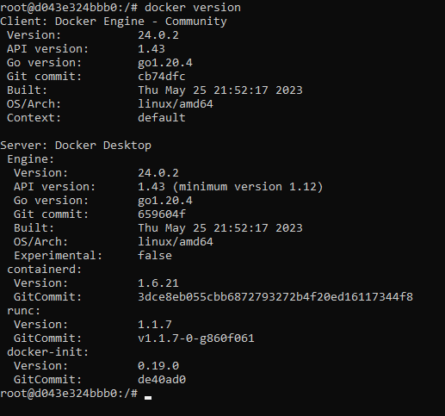

**3) what is plugins in jenkins ?**

Plugins in Jenkins are add-on components that extend and enhance the functionality of the Jenkins automation server, providing additional features and integrations for tasks like source code management, build tools, testing, deployment, notifications, security, and UI enhancements.

4) Create free style project and link it to private git repo containing any dockerfile then biuld an image from this dockerfile and push it to private docker repo

- Git configuration

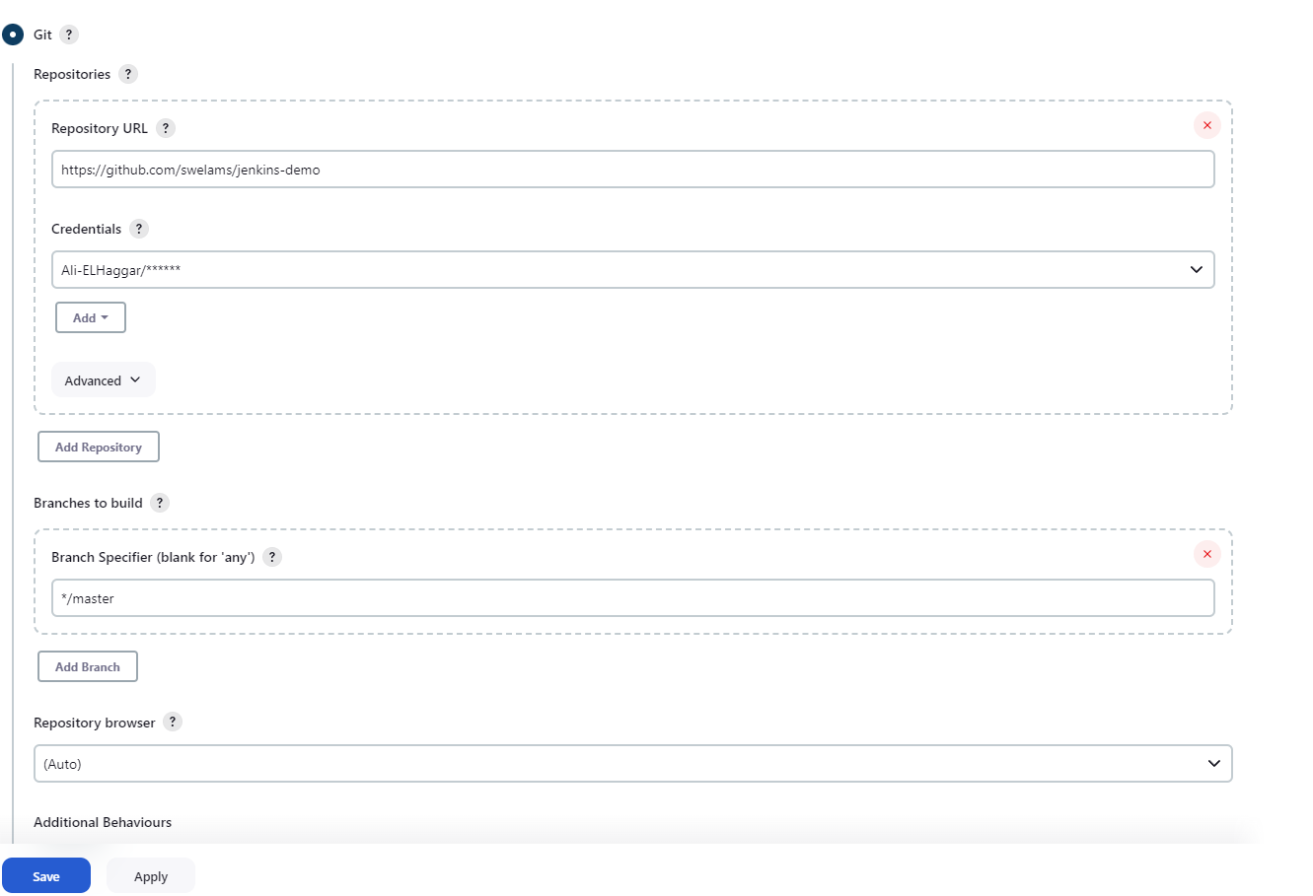

-Shell excute

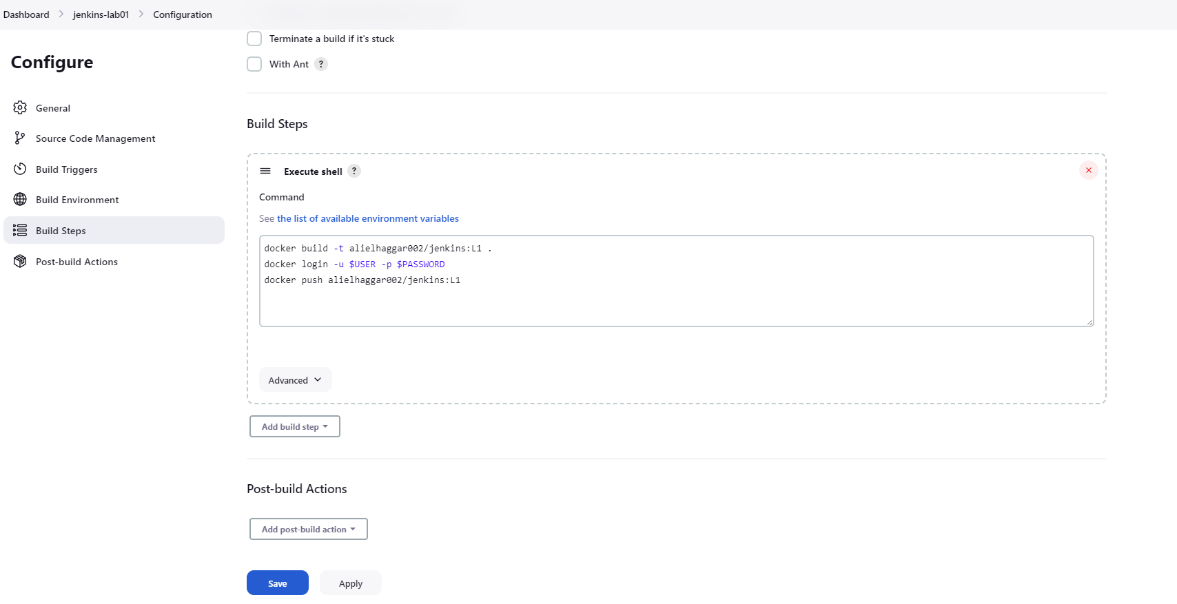

-Build Output

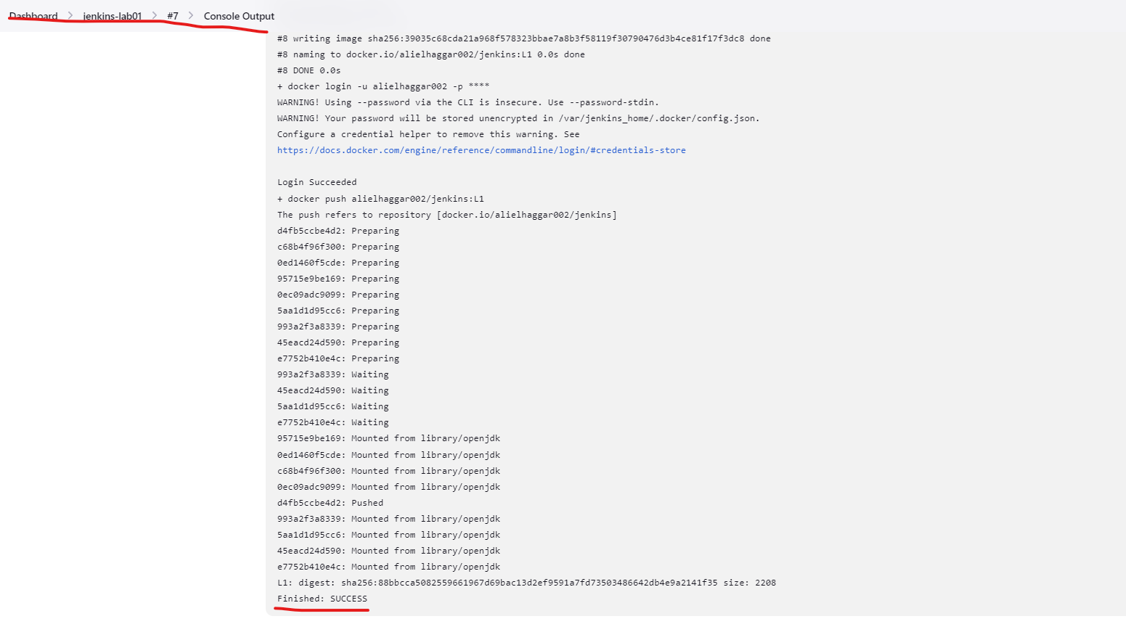

-Image Uploaded to Private repo

